Forest Health Index Activity

Read the introduction, About the Indicators, and What Does the Score Mean? on the home page.
- What two things do they claim affects forest health?
Click or tap here to enter text.

- What is each indicator score based on?

- What does it mean if an indicator score is 0?

- For each indicator, write how you think it will affect forest health or how it results from forest conditions. Do not merely write the description from the website; what is your hypothesis.

Indicator | Relationship to forest health
Frost Free Days  Example: | I think having more frost-free days would have a negative effect on forest health because the snowpack would melt too quickly, and pest and disease would have longer to remain active and cause damage
Temperature | Click or tap here to enter text.
Precipitation | Click or tap here to enter text.
Stream Flow | Click or tap here to enter text.
Snowpack | Click or tap here to enter text.
Critical Fire Risk | Click or tap here to enter text.
Extreme Temperature | Click or tap here to enter text.
Bear Mortality | Click or tap here to enter text.
Soil Moisture | Click or tap here to enter text.
Insect and Disease | Click or tap here to enter text.

Select Area:
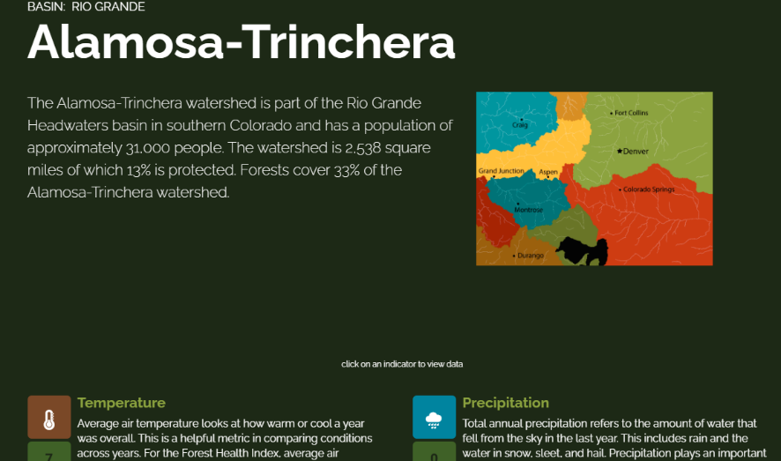
Click on the Rio Grande Basin on the Map: Select any of the smaller watersheds.

Name of your selected watershed ____Click or tap here to enter text._________

- Choose 3 indicators to analyze for your selected area. Answer the following questions
Indicator: Click or tap here to enter text.
What trends do you see?
Click or tap here to enter text.

What does this mean for future forest health in your watershed?
Click or tap here to enter text.

Indicator: Click or tap here to enter text.
What trends do you see?
Click or tap here to enter text.

What does this mean for future forest health in your watershed?
Click or tap here to enter text.

Indicator: Click or tap here to enter text.
What trends do you see?
Click or tap here to enter text.

What does this mean for future forest health in your watershed?
Click or tap here to enter text.

- A lot of these indicators are interrelated and can affect one another. Predict how the following indicators would influence each other and explain your reasoning. After looking at the data, did you find any evidence to support your prediction? Then do the same for two indicators of your choice.
Indicator | Soil Moisture & Critical Fire Risk
Your Prediction and Reasoning | Click or tap here to enter text.
Evidence found | Click or tap here to enter text.
Conclusion (Does the data support your prediction? Why or Why not?) | Click or tap here to enter text.
What other data would you need to answer this question? | Click or tap here to enter text.

Indicator | You choose: Click or tap here to enter text.
Your Prediction and Reasoning | Click or tap here to enter text.
Evidence found | Click or tap here to enter text.
Conclusion (Does the data support your prediction? Why or Why not?) | Click or tap here to enter text.
What other data would you need to answer this question? | Click or tap here to enter text.

- Which indicator is most concerning in your selected watershed? Why do you think so?
Click or tap here to enter text.
- What forest health conditions do you predict for the next ten years?
Click or tap here to enter text.

